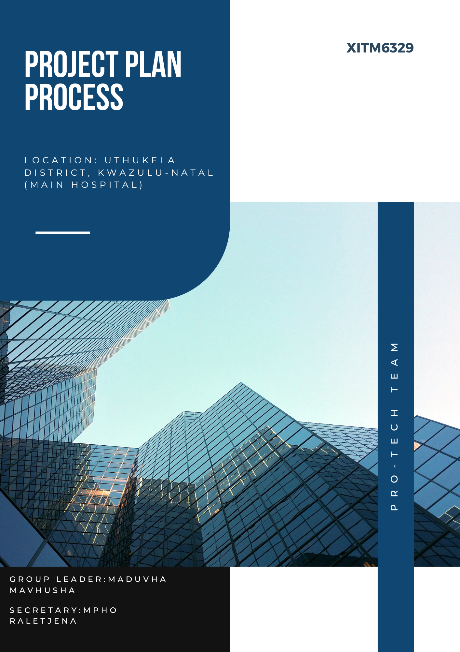

Project Plan Process.

Throughout this assignment process, the workload will be split amongst the 5 of us. So, the project plan assessment process is as follows below:

|  |  |
| --- | --- |
| Member name | Task |
| Maduvha Mavhusha | Maduvha is the group leader and is responsible for:   * Reviewing the final report and presentation for errors. * Provide feedback and make necessary corrections. * Ensure everything meets the assignment's requirements before submission. |
| Mpho Raletjane | Mpho is responsible for:   * Researching the prices of the network hardware and equipment needed for this task. * Ensure all references are properly cited. * Responsible for gathering all other necessary information and resources. |
| Chuene Tsholo | Chuene is responsible for:   * Draft the main body of the report or documentation. * Focus on structure, clarity, and adherence to assignment guidelines. |
| Masana Mavhusha | Masana is responsible for:   * Creating slides or any visual aids for the presentation. * Collaborate with the Writer to ensure consistency in messaging. |
| Ntsako Majozi | Ntsako is responsible for:   * Drafting the main body of the report or documentation. * Also, focus on structure, clarity, and adherence to assignment guidelines. |